DUE DATE: March 31, 2022

7 & 8th Grade Stewardship & Formation Activity Form
Please return to Charlotte Walton-Sweeney, DRE

Name of Candidate:

Total Hours | Date | Activity (description) | Parent Signature

DUE DATE: March 31, 2022

Confirmation Class of 2022 (8th grade) & 2023 (7th grade)

Report on the 7/8th Grade Stewardship & Formation Activity Project
Dear Candidate for Confirmation,
Prayerfully reflect upon all of the experiences that you have completed during your preparation for Confirmation. As part of your report on the overall experience, please include, but do not limit yourself to, the following:

- What are your feelings about the experiences/activities that you participated in the past two years?
- Whom did it benefit?
- What did you learn?
- What Christian values did you enhance within yourself?
- Which experience was most meaningful to you and why?
- What difficulties did you experience, if any?

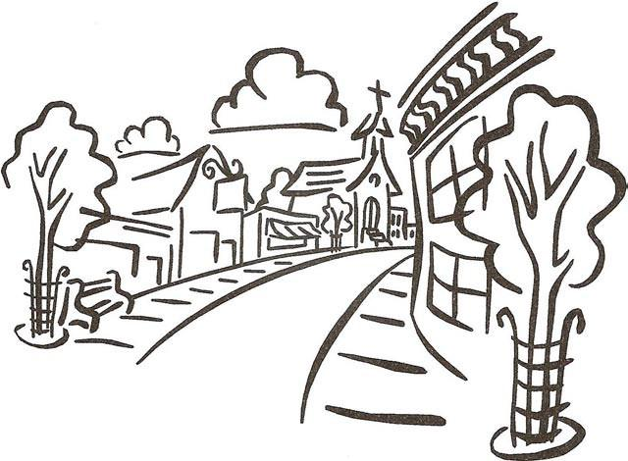
Please neatly write or type your report. Sign it and type or print your full name beneath your signature. Give your completed report as well as your completed Stewardship and Formation Activity Report form for this year to your teacher. Parents and Sponsors are asked to read the Report prior to submittal to the teacher.

Please return to:
Charlotte Walton-Sweeney
Director of Religious Education

