DUE DATE: March 27, 2022

Confirmation Class of 2022

LETTER TO BISHOP GAINER

Each Confirmation candidate must write a letter to Bishop Gainer.

The following information must be included as a part of the letter:

1. Why I want to be confirmed.
- The reason I chose the person I did to be my Sponsor.
- The reason for my choice of a Confirmation name. W h a t is it about the life of the patron saint whose name I chose, that I find particularly meaningful to me?

Letters must be typed or NEATLY handwritten. Parents and Sponsors are asked to read the letter before it is submitted to the DRE. The Candidate should print (or type) his or her full name beneath his/her signature.

The signature of the parent/guardian must also be on the letter.

Please remember to date the letter and sign it in blue or black ink.

All letters are to be turned into the Director of Religious Education. DO NOT send the letters to the Diocese independent of the class, Parish, DRE – they will not be accepted.

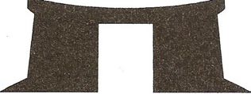

Please return to:
Charlotte Walton-Sweeney, DRE

